Unit 3 - Lesson 3 - Part 3: Operational Phase
Lesson 3 of 5

Lesson Objectives
In this lesson we aim to:
Understand ISO 19650 part 3, and the operational phase of an asset.
⧉ Audio placeholder (00:22) — no local audio matched this placeholder

Operational Phase
As you can see, a huge portion of information management in relation to an asset, and also the bulk of an assets life is during the operational phase.
⧉ Audio placeholder (00:23) — no local audio matched this placeholder

Asset Data
ISO 19650-3 replaced PAS 1192-3 in the UK which was published in 2014 and applicable until part 3 release in 2020.
⧉ Audio placeholder (00:22) — no local audio matched this placeholder
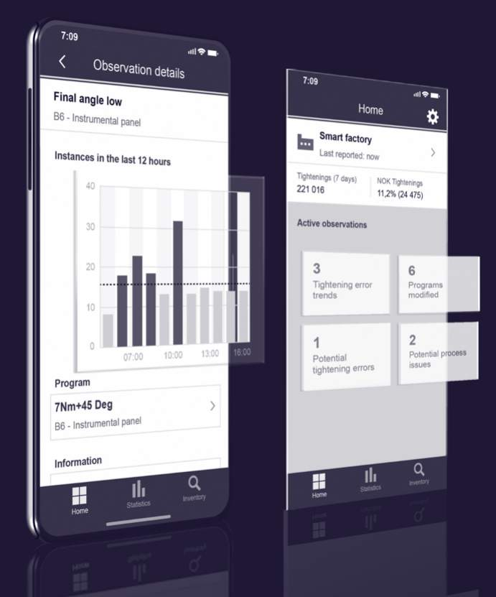
Data is considered the new gold!

Principles
ISO 19650-3 is designed to sit alongside and compliment part 2 and as such you will see many similar processes . This is so they can be utilised over the delivery and operational phase of an assets life.
There are however four key principles that are different:
Trigger Events:
Trigger events have carried over from the PAS standards. Those that can be foreseen and planned for, and those that cannot. an example of planned may be yearly maintenance.

Information Management Flow Chart
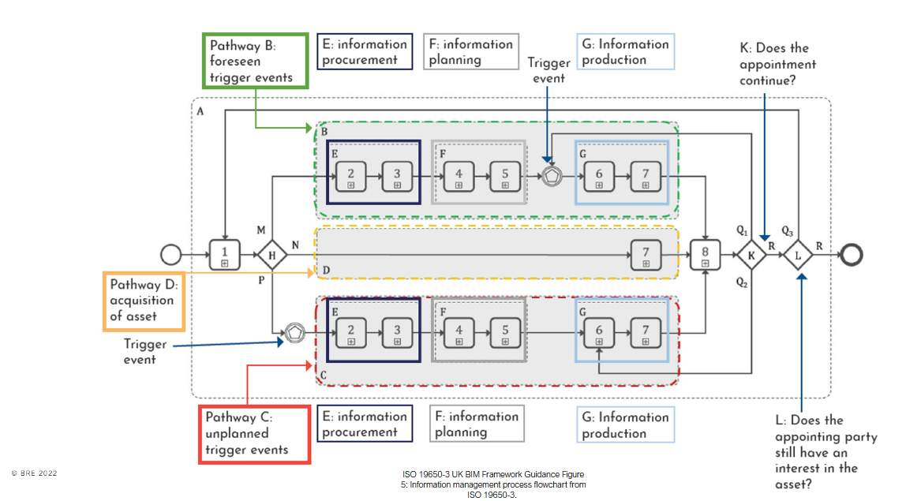
Click on the image to expand.

Activity groupingsA – encompasses all activities during operational phase B – activities per each appointment (before a trigger event)C - activities per each appointment (AFTER a trigger event)
Step 1 leads to three different pathways, shown as shaded boxes labelled B, C and D depending o the trigger eventWithin the pathways B and C, the process isbroken into 3 sub-groups labelled E, F and G.Sub-group E is about procurement – of a tier 1 contractor or an in-house teamSub-group E is about procurement – of a tier 1 contractor or an in-house teamSub-group G is about production – when information is produced by appointed parties, reviewed by a lead appointed party and ultimately accepted by the asset owner/operatorThe process has feedback loops at points K and L.

Lesson Summary
Lesson complete! You are now able to:
Understand ISO 19650 part 3, and the operational phase of an asset.
[CONTINUE]

